1) what is softwere ? what is softwere engineering ?

--> softwere is a set of instruction,data used to operate computers and tasks...

--> softwere is a part of computer that we can not touch physically...

2) explain types of softwere.

--> here the total five type of softwere ..

1.application softwere

2.system softwere

3.driver softwere

4.middleware softwere

5.programming softwere

1.application softwere :-

--> application sofwere is the most important in computer..it is performs to specific function for a user in the some of application..

--> application is a sum of programs and program run the application for the user...

--> example :- microsoft office,powerpoint etc..

2.driver softwere :-

-->device driver control the device and connected to computer to perform their tasks..

--> example :- games controller,usb storage device,key board,headphone etc...

3.middleware softwere :-

--> middleware is in between system softwere and application softwere it is known as middleware softwere..

--> it is also known as send a work from an application to computer..

4.programming softwere :-

-->programming softwere is used to write code for computer programmer..

-->programming softwere and tools is enable for developing,testing,etc..

--> example :- turbo c etc..

3) what is SDLC ?explain each phases of SDLC.

--> SDLC :- SOFTWERE DEVELOPMENT LIFE CYCLE

--> it has totle six phases-->1.REQUIRNMNET GATHERING

2.ANALYSIS

3.DESIGN=FRONTEND PART

4.CODING=BACKEND PART

5.TESTING

6.MAINTENANCE

what is DFD ?Creat DFD diagram on flipcart..

--> DFD is the data flow diagram..The flow of data of a system or a process is represented by DFD.

-->there are three types of DFD..1) 0- LEVEL DFD

2) 1-LEVEL DFD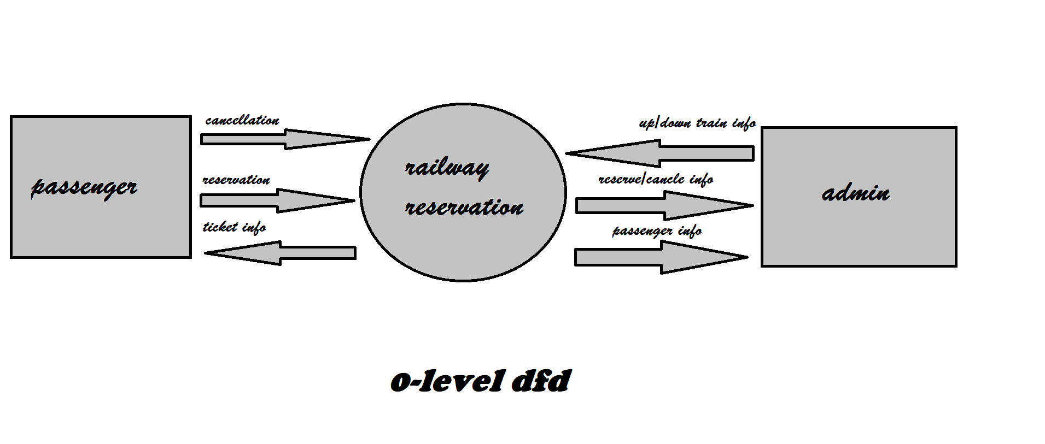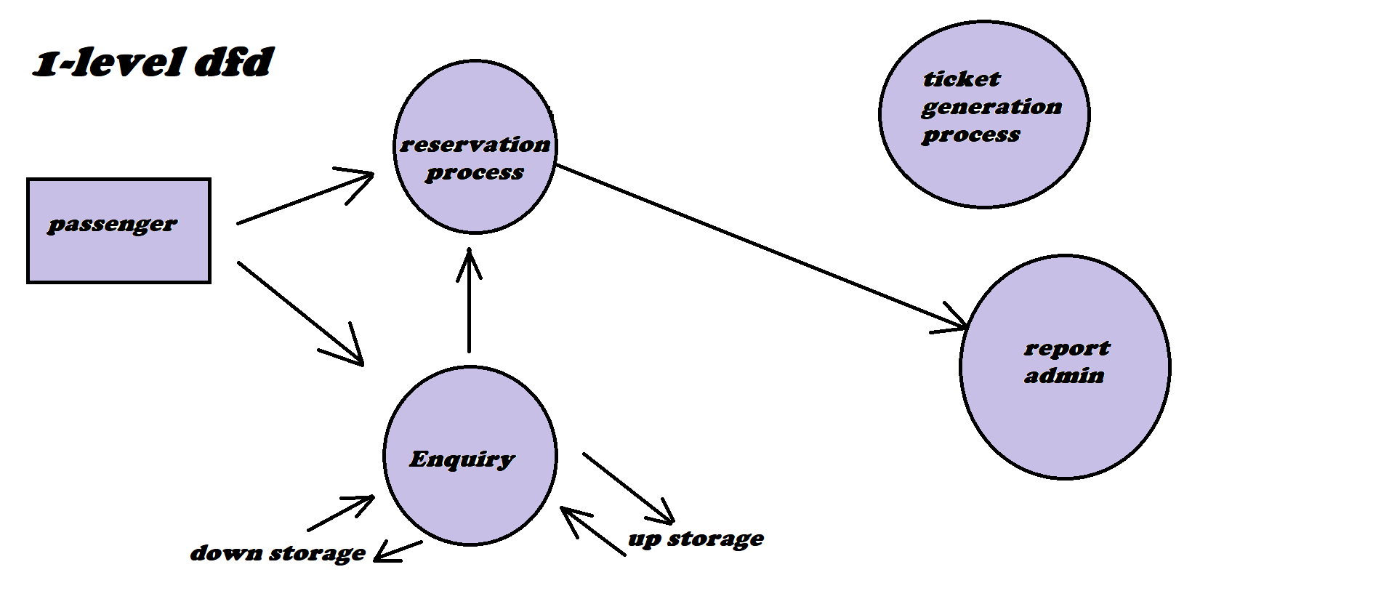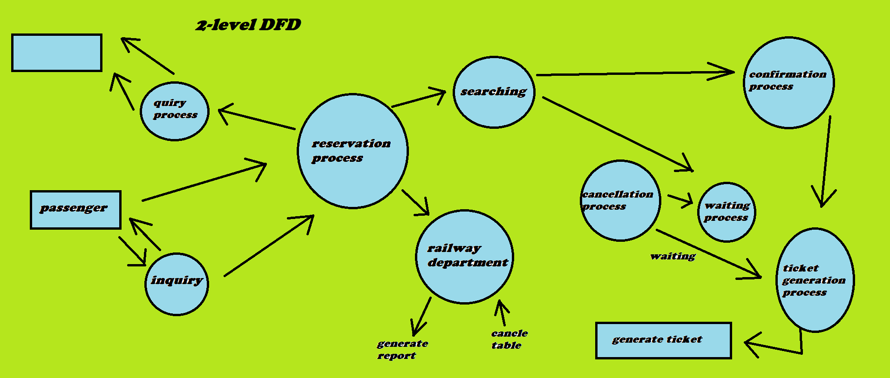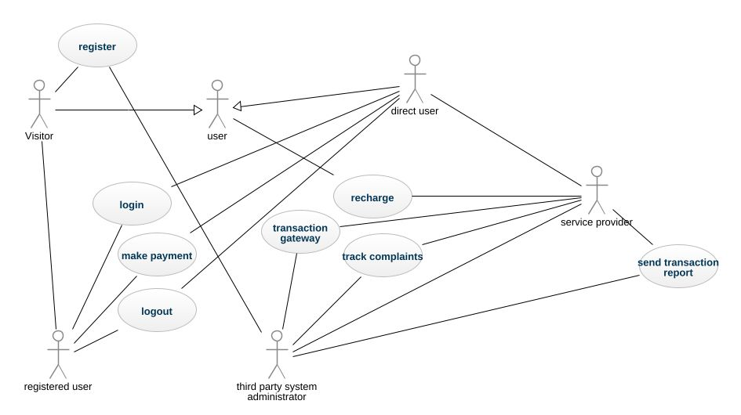

3) 2-LEVEL DFD

what is flow chat ?create a flowchart to make addition of two numbers

--> A flowchart can also be defined as a diagrammatic representation of an algorithm.

--> a step-by-step approach to solving a task.

what is flow chart ?create use-case on bill payment on paytm.

-->A use case diagram is a graphical depiction of a user's possible interactions with a system.